The potential utilization of Water Hyacinth mixed Rice Straw as Raw Material of Bioethanol

Ellina S. Pandebesie^{1*)}, Inike Lamria Siregar¹⁾, Susi A.Wilujeng¹⁾, Warmadewanthi¹⁾
¹⁾Institut Teknologi Sepuluh Nopember, Indonesia
* email: ellinasitepu@gmail.com
Keywords: Bioethanol; fermentation; pretreatment; rice straw; water hyacinth
Introduction
Water hyacinth (Eichhornia crassipes) is one of the water plants, has a fast growing and spreading, thus becoming a weed in many water bodies in Indonesia.This can cause negative impacts, because the water flow is inhibited, thus causing suspended solid sedimentation. Slow water flow and sedimentation lead to water hyacinth growth faster, resulting in decreased water quality (Amaral, 2012). These negative impacts can be solved by cleansing water hyacinths from water bodies or using them as raw materials for various products. Some studies suggest that materials have lignocellulosic structure (Mood et al., 2013), such as water hyacinth and rice straw can be converted into reducing sugars, then potentially into bioethanol. Water hyacinth contains 48% hemicellulose, 18% cellulose, and 3.5% lignin (Nigam, 2002). Currently rice straw partly used as animal feed and mostly burned. Burning rice straw can cause air pollution of the surrounding area, so there must be a more useful solution. Rice straw contains 31.7% hemicellulose, 41.2% cellulose, and 21.8% lignin.
Lignocellulose is considered the most profitable source of bioethanol due to its abundant and relatively inexpensive availability, especially in Indonesia. Bioethanol is an environmentally friendly biofuel with a content of 35% oxygen capable of causing a more complete combustion process, resulting in lower combustion hydrocarbon emissions (Ganguly et al., 2012). The purpose of this study was to determine potential of lignocellulose as raw material and the composition of water hyacinth and rice straw to produce maximum bioethanol.

Material and Methods
The raw material of water hyacinth is obtained from waters area in Institut Teknologi Sepuluh Nopember (ITS), while rice straw is obtained from suburban area of Surabaya. After dried and crushed into powder, water hyacinth and rice straw is mixed with a total weight 100 grams. Mixed ratio were 100: 0; 75:25; 25:75; 0: 100 respectively. Mixed substrate dissolved into 1000 mL aquadest, then added H₂SO₄ until it reaches a concentration of 1% solution. It was heated at 100 ° C for 60 minutes. On hydrolysis stage each sample was added mixed of T. viride and A. niger with a 2: 1 ratio, and pH maintained 5. Glucose content after pretreatment and hydrolysis were analyzed by Chesson method. At the fermentation stage, the filtrate of the hydrolysis product is added variation of S. cerevisiae 50 mL and 100 mL for each reactor. Sampling were conducted after 48 hours, 72 hours, and 96 hours fermentation. Concentration of bioethanol were analyzed by using Gas Chromatography method.
Results and Conclusions
Increased glucose content after hydrolysis process
Table 1.1 shows the glucose content increased after the hydrolysis process up to 87%. This demonstrates the effectiveness of T. viridae and A. niger to break down hemicellulose and cellulose. Lin et al. (2012) states that the concentration of glucose on the substrate will be directly proportional to the concentration of bioethanol produced.

Perbandingan Kandungan Bioethanol pada variasi penambahan mikroorganisma
Figure 1.1 is one of the results of chromatogram analysis of sample 75:25 by adding 50 mL S. cerevisiae, showing peak at retention time of 2.761 minutes with area intensity of 451.25604 pA. Tabel 1.2 shows the calculation results from Figure 1.1 produced bioethanol 1.58 mg/g on 96 hours. Similarly, Table 1.2 also shows in addition 100 mL of S. cerevisiae, the highest bioethanol concentration was produced in the 75:25 mixture on 96 hours, which was 3.50 mg/g. This analysis is calculated based on the wet weight. This bioethanol concentrations were smaller than those of Abednifar et al. (2009) research, with ethanol content of 0.37 g/g for rice straw.
The amount of bioethanol concentration is influenced by temperature, time, pH, dosage, microorganism performance, and sugar concentration during fermentation process (Lin et al., 2012). Previous pretreatment and hydrolysis processes may also affect this fermentation process. All reactors showed bioethanol concentrations incresed to 72 hours, but after 96 hours several reactors decreases, such as both reaktor of 0:100. Decrease in bioethanol concentration at 96 hours can occur due to the reduction of sugar content in the substrate has been fermented by microorganisms and the formation of inhibitors in the substrate of lignin, weak acid, and phenolic compounds derivative. The higher the reducing sugar, the higher the ethanol produced. Somehow, different things happen in this study, the highest reducing sugar content is produced in the 100: 0 mixture. However, the highest bioethanol concentration is achieved in the 75:25 mixture. This may be due to inhibitors generated in the 100: 0 mixture, or microorganisms do not work optimum because pH is not appropriate. The optimum pH state during the fermentation process is pH 4 (Lin et al., 2012).
References
Abednifar, S., Karimi, K., Khanahmadi., dan Taherzadeh, M. J. 2009. Ethanol production by Mucor indicus and Rhizopus oryzae from rice straw by separate hydrolysis and fermentation. Biomass and Bioenergy vol. 33, pp: 828-833.
Mood, S.H., Golfeshan, A.H., Tabatabaei, M., Jouzani, G.S., Najafi, G.H., Gholami, M., dan Ardjmand, M. 2013. Lignocellulosic Biomass to Bioethanol, a Comprehensive Review with a Focus on Pretreatment. Renewable and Sistainable Energy Reviews vol.27, pp: 77-93.
Nigam, J.N. 2002. Bioconversion of Water-Hyacinth (Eichhornia crassipes) Hemicellulose Acid Hydrolysate to Motor Fuel Ethanol by Xylose–Fermenting Yeast. Journal of Biotechnology vol. 97, pp: 107-116.
Ganguly, A., Chatterjee, P.K., dan Dey, A. 2012. Studies on Ethanol Production from Water Hyacinth – A Review. Renewable and Sustainable Energy Reviews vol. 16, pp: 966-972.
Lin, Y., Zhang, W., Li, C., Sakakibara, K., Tanaka, S., dan Kong, H. 2012. Factors Affecting Ethanol Fermentation using Saccharomyces cerevisiae BY4742. Biomass and Bioenergy xxx, pp: 1-7.

Table 1.1 Increased glucose concentrations
Substrate | Glucose after pretreatment  (mg/g) | Glucose after Hydrolysis  (mg/g) | Increased  (%)
100 : 0 | 3,149 | 24,863 | 87
75 : 25 | 2,769 | 20,059 | 86
25 : 75 | 2,184 | 8,667 | 75
0 : 100 | 1,845 | 6,098 | 70

Tabel 1.2 Bioethanol Concentration on Fermentation Stage
Substrate | Bioethanol Concentration (mg/g)
Substrate | 50 mL S. cerevisiae |  |  | 100 mL S. cerevisiae
Substrate | 48 hr | 72 hr | 96 hr | 48 hr | 72 hr | 96 hr
100:0 | 1,40 | 1,41 | 1,22 | 2,41 | 2,42 | 3,02
75:25 | 1,12 | 1,30 | 1,58 | 2,34 | 2,60 | 3,50
25:75 | 0,82 | 0,87 | 1,23 | 2,05 | 2,87 | 3,21
0:100 | 0,91 | 1,33 | 1,15 | 1,00 | 1,70 | 1,38
.
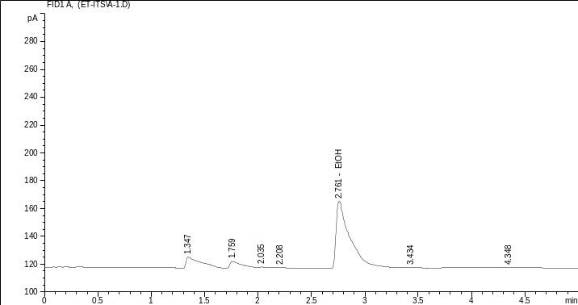
Figure 1.1 Result of gas chromatographic analysis for bioethanol

